­­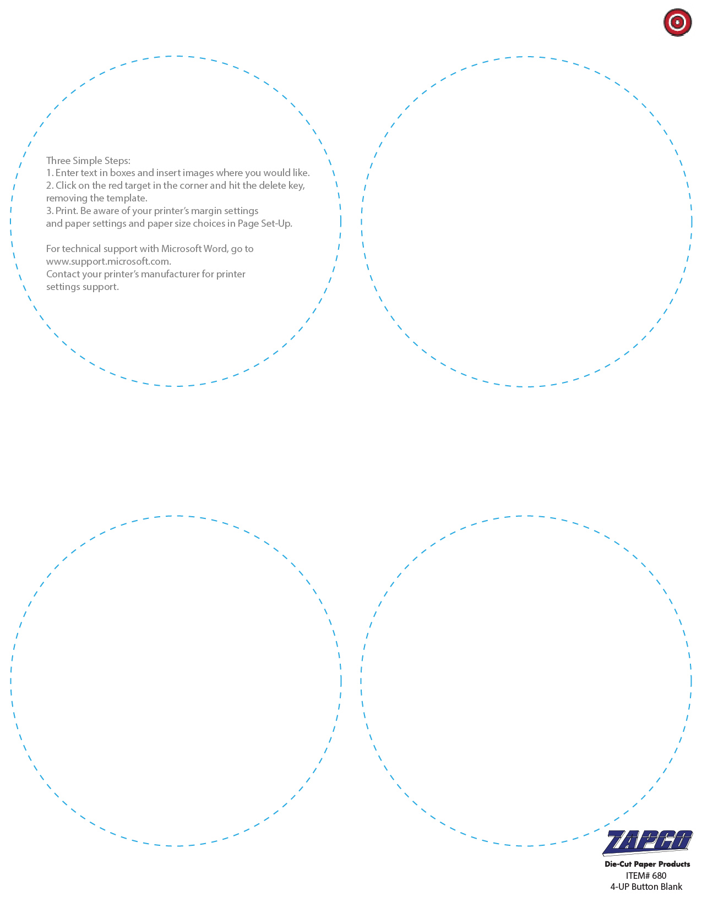

Enter Text and Pictures Here

Enter Text and Pictures Here

Enter Text and Pictures Here

Enter Text and Pictures Here